**Week 5 blog post**

**Topic –**

Week 5 – Table View Controller and segue

Trip app

**Snapshot of the final product -**

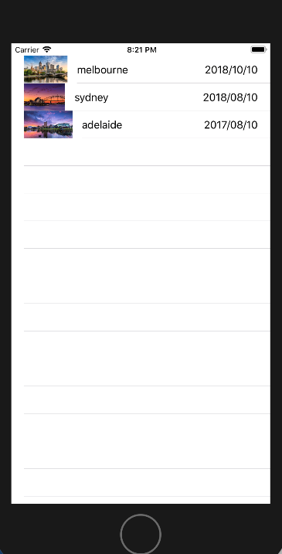

Fig 29: Final view of the app

**How I implemented –**

For the trip app we were provided with a swift file named trip.swift. And we were introduced with the concept of tableViewController. So I had to delete the initial view controller and Add two new view controllers one for the trip information and one for trip details. I also added to cocoa touch class files so that I could code the two table view controllers. I added the identifier name of the prototype cell for the first view controller(trip Info) and and chenged the table contents to static cells with 3 rows for the second view controller(trip details). I also added some labels and text fields.

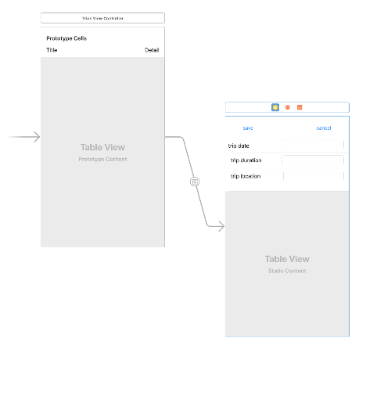

Fig 30: Snapshot of the main storyboard

Then I added images of melbourne, adailede and sydney for displaying the city picutures in my app. I also made some changes in the first view controllers as shown below. Also I have performed some segue functions where I connected the prototype cells of the first view controller to the second view controller table for performaing segue functions.

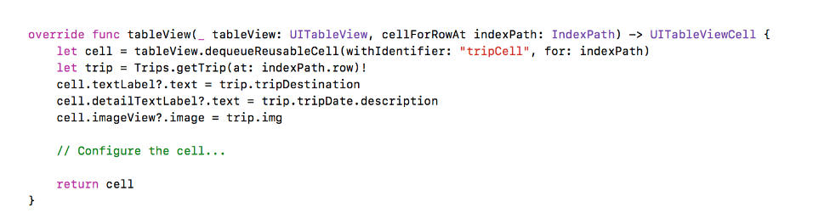

Fig 31: Small snippet of the trip info table view controller.

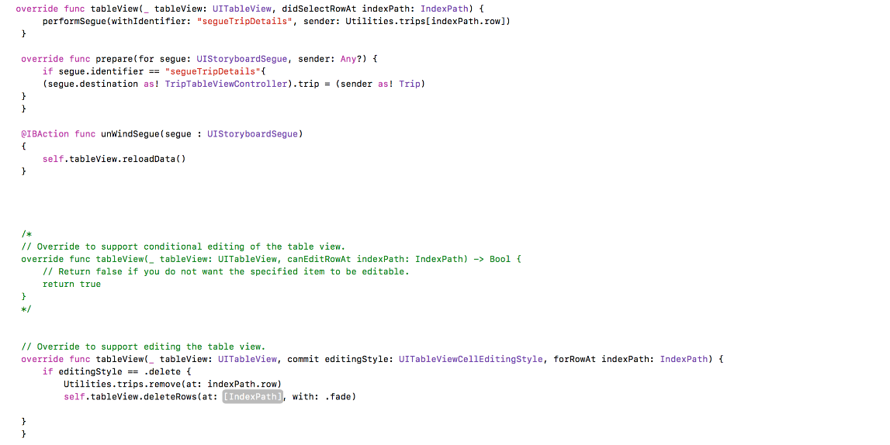

Fig 32: Small snippet of trip info table view controller showing various important functions.

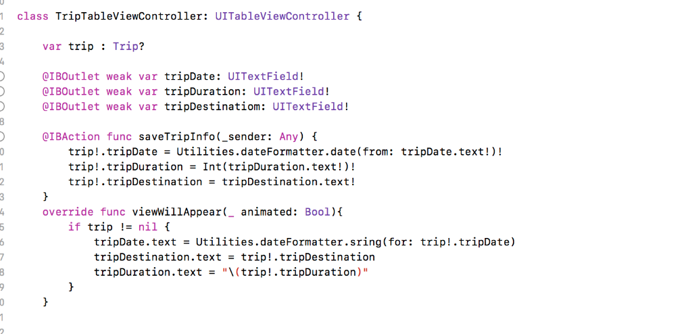

Fig 33: Snippet code of the TripTableViewController(trip details)

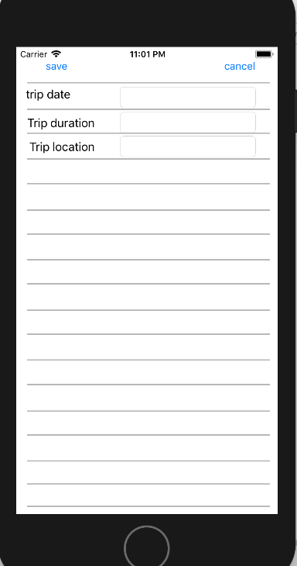

Fig 34: Simulator view of the trip details view controller(second table view controller)

For the github implementation I created a respiratory on github and in the terminal I created a root directory in the MAC for saving this project and kept on updating on github everyweek as the application progressed.

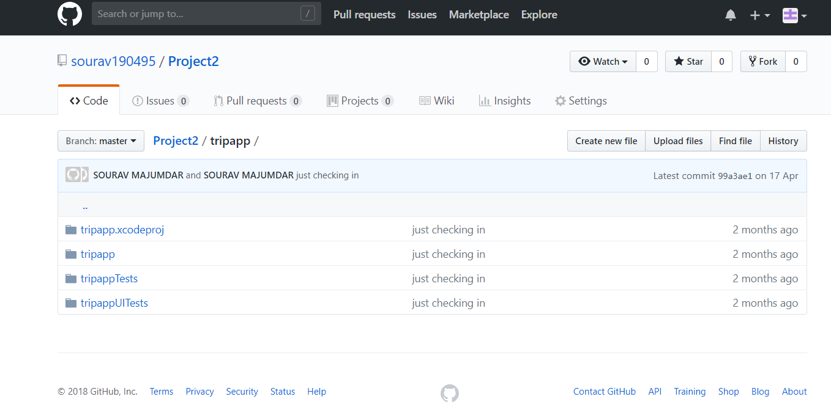

Fig 35: Snapshot of github respiratory.

**Reflection -**

In this week I finished my assignment 1 and now looking forward for assignment 2. This weeks lab was pretty interesting, as we were introduced with the tableViewController concept which invloves navigation from different table views. I also learnt about segues and how to implement them, which I will definitely use in future. This application continues in week 6 for map implementation, so I am very much excited for nect week. I also added this project on Github, hence I acquired some more knowledge about github and its implementation. Since I decided to work on a weather applicaton for assignment 2, which works on tableViewControllers, hence this lab was very much useful for me.